ch
1.
A Project Report On



Submitted in partial fulfillment of the requirement for the award of the degree

Bachelor of Computer Application (BCA)

Academic Year 2023 – 24
(Aryan Ponkiya) 92200527253
(Divyesh Gangah) 92200527243
(Harsh Thobani) 92200527002

Internal Guide
(Prof. )



Rajkot-Morbi Road, At & PO : Gauridad, Rajkot 360 003. Gujarat. India.

Faculty of Computer Applications (FCA)


This is to certify that the project workentitled
Chatting App
submittedinpartialfulfillment of therequirement for the award of the degree of

Bachelor of Computer Application

of the
Marwadi University
is aresult of the bonafide work carried out by

Aryan Ponkiya(92200527253) Divyesh Gangah(92200527243) Harsh Thobani(92200527002)

during the academic year 2023-24

Sunil Bajeja Shridharan Sir

Faculty Guide |  | HOD |  | Dean

DECLARATION

We hereby declare that this project work entitled Chatting App
is a record done by me.

I also declare that the matter embodied in this project is genuine work done by me and has not been submitted whether to this University or to any other University / Institute for the fulfillment of the requirement of any course of study.

Place : Marwadi University – Rajkot Date : 10/4/2024

Aryan Ponkiya (92200527253)

Divyesh Gangah (92200527243)
Signature : Aryan

Signature: Divyesh

Harsh Thobani (92200527002) Signature: Harsh

CONTENTS
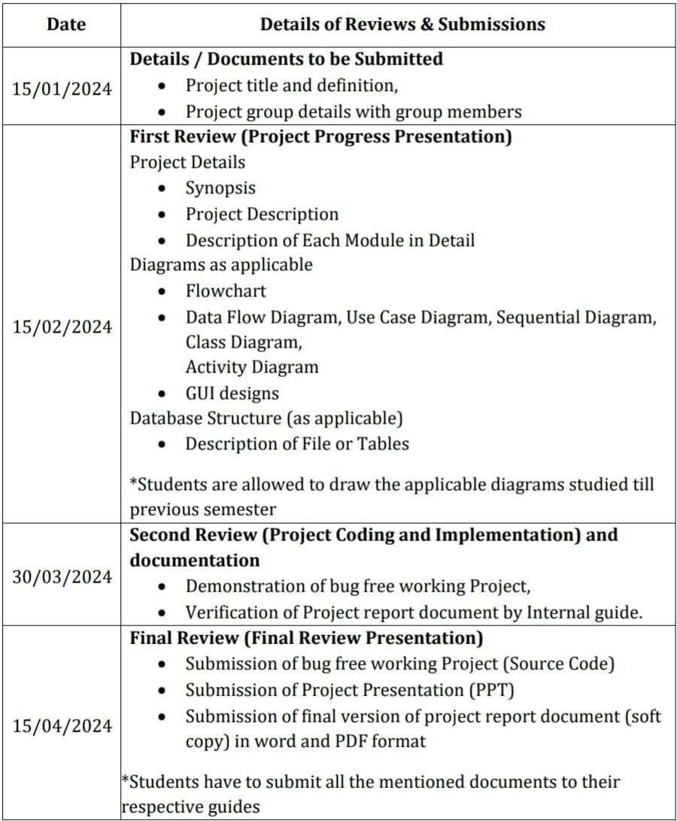

PROJECT DETAILS

  - SYNOPSIS

A chatting app is a digital platform that allows users to communicate with each other in real-time through text messages. It typically features a user-friendly interface where individuals can send and receive messages instantly. Whether for personal or professional use, chatting apps make staying connected easy and convenient.

PROJECT DISCRIPTION

The chatting app is designed to communicate with each other. It is usually designed for private chatting with friends, family members and other people. It is use for fast and secured communication. It also having the feature for save the chatting history. This app have simple inter face and simple build.

ALGORITHM AND FLOWCHART

- Algorithm

Step 1: Start.

↓

Step 2: Enter the message whatever you like to send to other person

↓

Step 3: Send the message you write.

↓

Step 4: Read the message that sender send you.

↓

Step 5: End













FLOWCHART
Start
Send message to the
reciever
End
Read the message that sender
send you
Write the message




  - DATAFLOW DIAGRAM

User Name

User ID

Save Chat

Chatting System

Login

Add message

User Account

USECASE DIAGRAM







User name

Save Chat

Add User

User account

Login

User ID

SEQUENTIAL DIAGRAM
communicate
Log In

User
System Manager

Admin

Send message
Send message

Creat
e
ount

Save Chat

Update/Delet
e Accoun
Acc
Forward Request

ACTIVITY DIAGRAM

EMPLOYEE

Login

Verify

Account Send Request Reports

Change Password Send Message Sender Recieve

Send

- Entity Relationship Diagram

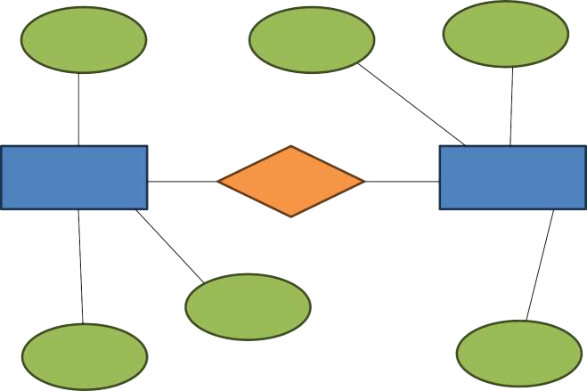
Email
ID
Username
User
Has
Login
Name
Phone
Password

Test Cases

Choose user names:

Input - “Enter user name”

Output – Asks you, which user name you like to give.

Confirm the user name:

Input – “Click on join button”

Output – It confirms that you’re user name has been applied.

After clicking the join button:

Input – “Click to join button”

Output – Now, You are now joined the chatting group in chatting app.

After joining the group

Input – “Click on join button”

Output – It shows you that now you are connected with server.

After joining the group

Input – “Click on join button”

Output – It shows you that you and your chat partner now joined the chat.

Write the message

Input – “Write the chat”

Output – Your message is now ready to send.

Send the message

Input – “Click on the send button”

Output – Your message was send to receiver.

Receive the message

Input – “Send the message to another user”

Output – Now, Your chat partner receive the message.

LEARNING DURING PROJECT

- Choose a simple project
  - Select a small project idea is that aligns with your current level of Python language knowledge. Example could include Chatting App.

- Study Relevant Concepts
  - As you encounter new concepts and functions, refer to Python language documentation, textbooks, or online tutorials to understand them batter. Topics like variables, loops and functions are essential.

- Write code incrementally
  - Start with the basics and build your project incrementally. Test each part as you go to ensure it works before moving on to the next.

- Debugging
  - Debugging is important part of the learning process. When you encounter errors, use debugging tools and print statements to identify and fix them.

- Share and Discuss
  - Share your project with others, whether it’s friends, mentors, or online communities. Discussing your code can lead to valuable insights and suggestions for improvement.

BIBLIOGRAPHY

  - Online Refrances
    - “Pythontutorial” → W3Schools
    - YouTube → ‘Codewithherry’

THANK YOU
(Specially, To our project Guide)

